Media Release
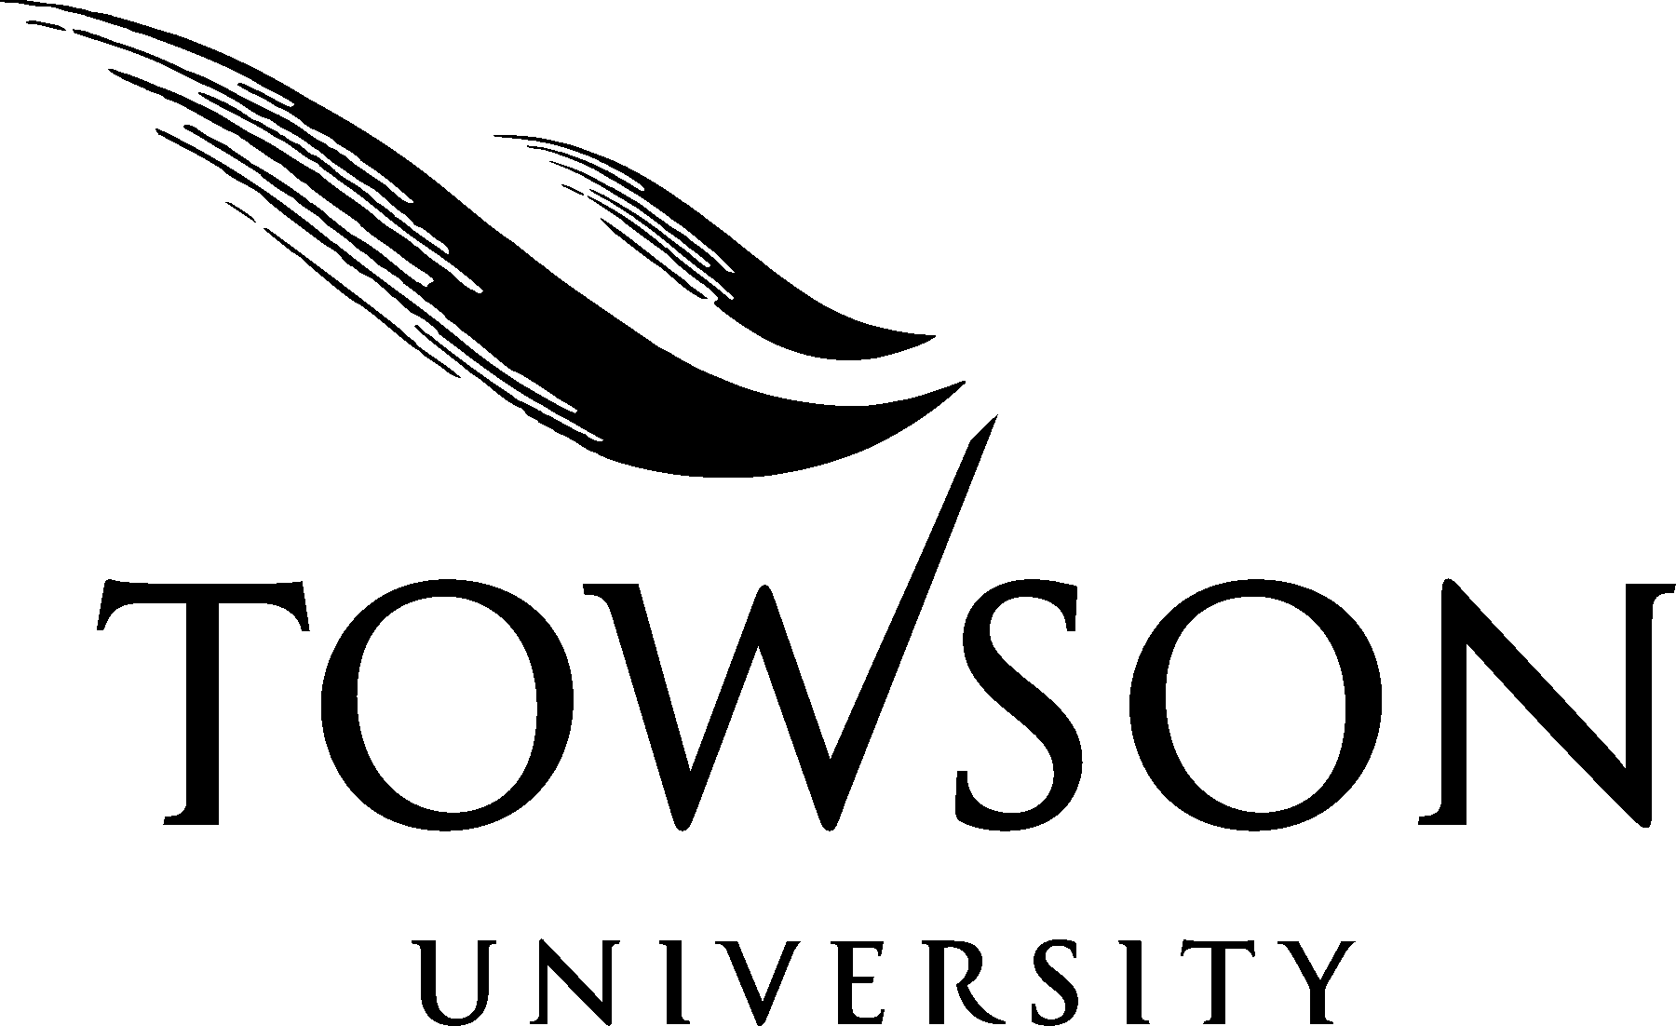

FOR IMMEDIATE RELEASE
August 12, 2005
Contact: Carol Dunsworth
410-704- 4672
cdunsworth@towson.edu

Towson University earns $50K grant to prepare
first-generation college-bound students

University Relations  Towson University  8000 York Road  Towson, MD 21252-0001  t. 410-704-2230  f. 410-704-2328 | TOWSON, Md. – Through a College Preparation and Intervention Program (CPIP) grant, Towson University’s Division of Economic and Community Outreach (DECO) is working to better prepare students for the mathematics portion of the SAT exam and to help students become college-ready in mathematics.  The Maryland Higher Education Commission grant provides $50K in funding for a CPIP partnership to support a cohort of first-generation college-bound students who participate in Gaining Early Awareness and Readiness for Undergraduate Programs (GEAR UP). As a CPIP partner, Towson University will provide essential college preparatory support for GEAR UP students at Digital Harbor High School (Digital Harbor) in Baltimore, Maryland  This CPIP partnership will offer weekly after-school tutorial services for Digital Harbor GEAR UP students throughout their senior year, focusing on strategies for the mathematics portion of the SAT exam and general mathematics instruction. Under the guidance of a Towson University lead tutor, GEAR UP students will become peer tutors. The collaborative environment will encourage GEAR UP students to support one another just as college students often do through study groups on the college campus.  In addition, Towson University will participate in evening meetings to support GEAR UP parents and students throughout the college and financial aid application processes.  -30-  2005-049

