Senate Finance Committee
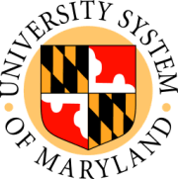
Hearing on SB 344
The Flexible Leave Act
February 21, 2008

Remarks by James E. Sansbury
Associate Vice Chancellor for Financial Affairs
University System of Maryland

Mister Chairman, members of the Committee, I am Jim Sansbury, Associate Vice Chancellor for Financial Affairs of the University System of Maryland.

I am here today to request that SB 344 recognize the autonomy provided to University System of Maryland by the General Assembly in Maryland Statute. It appears that SB 344 is meant for the private sector. However, as written, it also would apply to the University System of Maryland because the USM is an Independent Personnel System not subject to the provisions of Title 9, Subtitle 5 of the State Personnel and Pensions Article.

I also wish to point out that SB 344 is more restrictive than the Board of Regents Policy on Sick Leave in that the Board of Regents defines “Immediate Family” to include brothers, sisters, father-in-law, mother-in-law, brother-in-law, sister-in-law, any legal dependent of the employee, any family member who permanently resides with the employee in addition to the child, spouse or parent.

Thank you for considering our comments and I will be glad to answer any questions.

