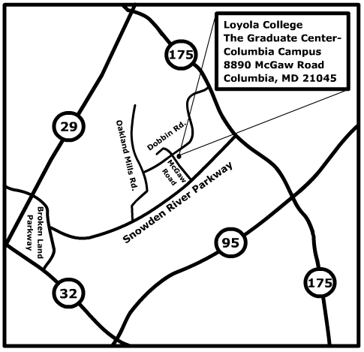
From our Previous Facility at 7135 Minstrel Way
- From Minstrel Way, turn left onto Snowden River Parkway
- Follow Snowden River Parkway to the 4th traffic light
- Turn left on McGaw Road, where you see Apple Ford
- Follow McGaw Road past the Gramophone store and just before the light at the intersection of McGaw and Dobbin Roads, turn right into the Graduate Center Parking lot.

Starting in the Summer 2003 semester, the Loyola University Maryland Graduate Center will be located at 8890 McGaw Road.

Directions from I-95:
- From I-95, follow 175 west towards Columbia
- From 175 west, take the 3rd exit, Snowden River Parkway. At the end of the exit ramp, turn left at the light to go south.
- Follow Snowden River Parkway to the 2nd light and turn right on McGaw Road, where you see Apple Ford.
- Follow McGaw Road past the Gramophone store and just before the light at the intersection of McGaw and Dobbin Roads, turn right into the Graduate Center Parking lot.

From the Baltimore Beltway 695:
- From 695 in Towson, take the outer loop toward Pikesville and take Exit #16-A, Route 70 west toward Frederick
- Follow Route 70 west and take the left exit onto Route 29 south toward Columbia
- Follow Route 29 south and exit onto Route 175 East
- Follow Route 175 East to the 3rd traffic light and turn right onto Dobbin Road
- Follow Dobbin Road to the 3rd traffic light and turn left onto McGaw Road.
- Immediately after the Dobbin/McGaw intersection, turn left into the Graduate Center parking lot.

