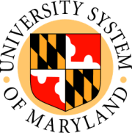

Board of Regents

Committee on Finance

August 20, 2009

Stamp Student Union
University of Maryland, College Park

Public Session

- Towson University: 2009 Facilities Master Plan Update (presentation and information)
- Towson University: Renovation Improvements to Burkshire Marriott Conference Hotel (action)
- Proposed Amendment to VIII-2.70 - Policy on Student Classification for Admission and Tuition Purposes (action)

