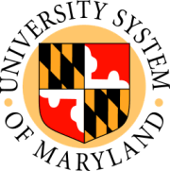 Revised 12/18/09
USM BOARD OF REGENTS
USM Office
Elkins Building
Chancellor's Conference Room
Tuesday, December 22, 2009

Agenda for Public Session 8:00 a.m.

A. Call to Order Chairman Kendall

B. Committee of the Whole Chairman Kendall
1. Memorandums of Understanding for Restructuring of UMBI (action)
a. Center of Marine Biotechnology (COMB)
b. Institute of Fluorescence (IOF)
c. Center for Biosystems Research (CBR)

2. University of Maryland, Baltimore County: Notice of Federal Interest (action)

3. Request to Address the Board James C. Rosapepe
Senator, Maryland General Assembly

Andrew M. Fellows
Mayor, City of College Park

Joseph L. Nagro
City Manager, City of College Park

Eric Olson
Member, Prince George's County Council

Dr. Ann Wylie
University of Maryland, College Park
Vice President of Administrative Affairs

4. Admissions and Amusement Tax (action) Chairman Kendall
C. Reconvene to Executive Session (action) Chairman Kendall

