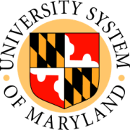

USM Board of Regents

Meeting of the Committee on Finance
Public Session
UMUC

10:00 a.m. September 25, 2008

- University of Maryland Biotechnology Institute: 2007 – 2017 Facilities Master Plan Update (information)
- University System of Maryland: Review of Capital Improvement Projects (information)

