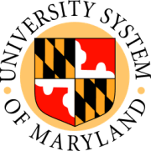

Board of Regents

Committee on Finance

June 16, 2009

Towson University

Public Session

- FY 2011 Capital Budget Request; and FY 2011-2015 Capital Improvement Program (action)
- FY 2010 System Funded Construction Program Request (action)
- University System of Maryland: Auxiliary Facility and Tuition Revenue
Bonds Twenty-Ninth Bond Resolution (action)
- University System of Maryland: Correction to Fiscal Year 2010 Schedule of Tuition and Mandatory Fees (action)
- Towson University: Dining Services Contract – Exercise Renewal Option (action)
- Financial Aid Report FY 2004 – 2008 (information)
- University System of Maryland: Review of Capital Improvement Projects (information)

