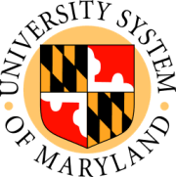

BOARD OF REGENTS ADVANCEMENT COMMITTEE

University of Maryland Baltimore County
Albin O. Kuhn Library
7th Floor
October 7, 2008
10:00 AM-Noon

Barry Gossett, Chair

AGENDA

- Welcome and Introduction of New Committee Member

- Review and Discussion of Charge/Mission* (Action Item)

- Campaign Update*
  - Attainment of $1 billion in funds raised to date
  - Milestones for several USM institutions

- Return on Investment of State Supplemental Funds Report*
  - Selected Highlights
  - Questions and Answers

- Benchmarking/Best Practices
  - UMBC Peer Study Report
  - Campaign Data Points

- Advocacy*
  - USM Regents Advancement Committee Role
  - Discussion of USM Foundation Role
  - Congressional Roundtable on College Endowments

- Future State Matching Fund Program Ideas*
  - Models from Other States
  - How to Differentiate from PDIP (Private Donor Incentive Program)

- USM Foundation Investment Performance
  - Preliminary Results FY 08

*Advance Materials

